Job Site Observation

Date of task: October 25, 2021 Location: Any Street
Time: 1255 hours to 1303 hours Task: Motor Stop for Motor Vehicle Violation

JSO by Chief_________ Crew: Anytown Police Officer

Hazards Controls
MV Traffic approaching from behind to travel through parking lot | Engineering-Location of MV Stop- In parking lot away from approach and oncoming traffic. Positioning of Patrol Vehicle - Angled
Inattentive Drivers of passing vehicles | Engineering – Emergency lights and flashers activated for visibility
possibly slippery pavement. | Administrative – Before exiting vehicle checks for traffic. Positions patrol vehicle to shield him any vehicle that might pass in parking lot and to utilize as cover.
Day Time – Sunny and Dry roadway | Engineering – POLICE in gold lettering in back of outer carrier & trousers with gold stripe for visibility
Officer becomes exposed while approaching stopped vehicle | Administrative- Officer positions patrol vehicle to maximize protection before exiting. Use position of patrol vehicle as shield for final approach. Officer stays out of crush zone when approaching stopped vehicle both times.
Unknown danger with operator i.e. wanted, person, weapons present etc… | Administrative – Officer visually checks interior while communicating with driver – Stands bladed to reduce exposure traffic

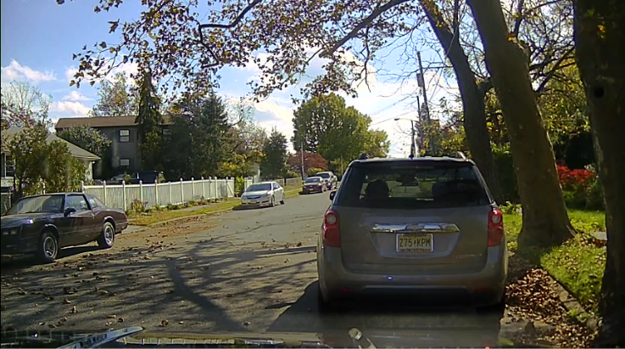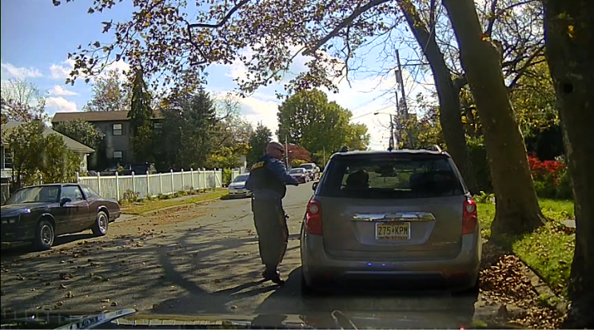

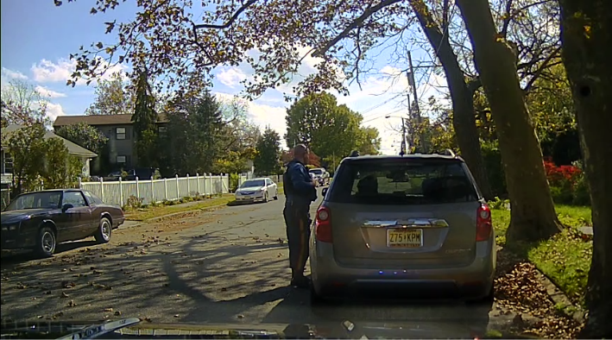
Location of MV Stop- Officer stops vehicle on side street to avoid road with little shoulder and high traffic volume. Officer positions patrol vehicle to maximize use of patrol vehicle as a shield. Patrol vehicle could be used as cover.

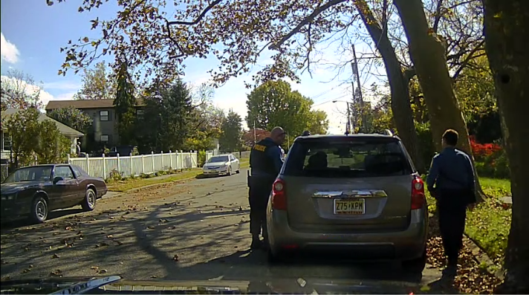
On final approach when a back-up officer is present, primary officer approaches driver’s side of stopped vehicle. This demonstrates the importance of proper positioning of patrol vehicle, contact and back-up officer.

Description of Task

On October 25 at 1255 hours, the above Anytown Police Officer was assigned to patrol duties in uniform and a marked patrol unit. It was during the daytime with the sun out and a dry roadway. The police officer observed a motor vehicle violation. The officer positioned his vehicle behind the suspect and activated the patrol vehicle’s emergency lights and flashers to conduct a motor stop for said violation. This portion of the roadway has a narrow shoulder. The officer stopped the vehicle on a side street, which has much less traffic. Once stopped, the officer positioned his patrol vehicle in a manner to provide protection from any traffic approaching from the rear. Additionally, the patrol vehicle was positioned in a manner so it could be used as cover if needed.
Officer’s initial approach bladed to the vehicle at B post. On the final approach when a backup officer is present, a primary officer approaches the driver’s side of the stopped vehicle. This demonstrates the importance of the positioning of the patrol vehicle at the time of the stop.

In Review of this work site observation:
The officer utilized the proper position of the patrol vehicle and self for safety and to maintain a tactical advantage. When there was more than one officer, the primary officer utilized the proper positioning of the patrol vehicle to make a safe approach to the driver’s side of the stopped vehicle.

Recommendations:
None

